Skin sample

Photodiode system

µController

Programming environnement (Matlab)

Recognition

Spectro-photometer

Conversion to environnement

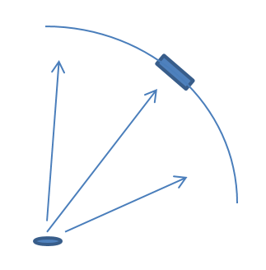

Sample of skin

Sensitive surface of the photodiode

Angle of scattered light